**Smart Agriculture System Proposal (1 Page)**

**Title: AI-Driven Smart Agriculture for Crop Yield Prediction**

**Overview:**  
This system aims to enhance agricultural productivity using AI and IoT. By collecting real-time data from farm environments through sensors, and processing it using AI models, farmers can make informed decisions about irrigation, planting, and harvesting to optimize crop yields.

**Required Sensors:**

1. **Soil Moisture Sensor** – Measures soil water levels to guide irrigation.
2. **Temperature Sensor** – Monitors environmental conditions that affect plant growth.
3. **Light Intensity Sensor** – Tracks sunlight exposure essential for photosynthesis.
4. **Humidity Sensor** – Detects atmospheric moisture levels impacting crop health.

**AI Model:**  
A **time-series model (e.g., LSTM)** or a **Random Forest regression model** will be used to predict crop yield based on continuous sensor readings. The model will be trained on historical environmental and yield data to learn patterns and make accurate predictions.

**System Benefits:**

* Optimize water and fertilizer use
* Improve decision-making with AI insights
* Reduce waste and increase crop output
* Enable smart, automated farming with low labor cost

**Data Flow Diagram:**

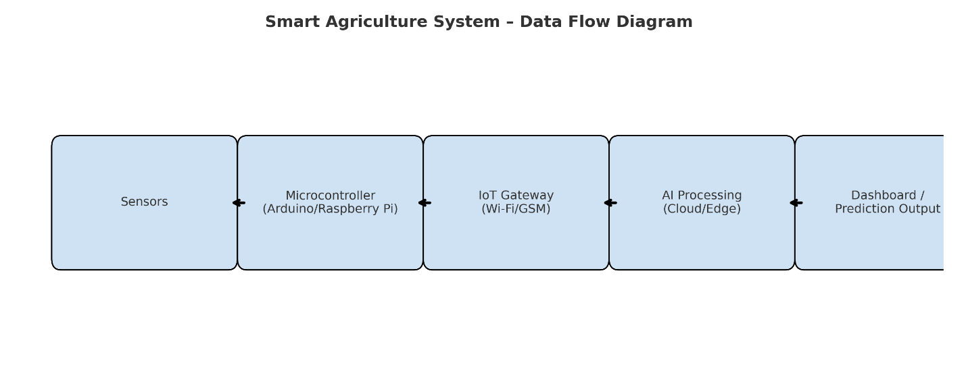

**Deployment:**  
The system can be deployed on small or medium farms using affordable hardware like Raspberry Pi and open-source AI platforms like TensorFlow or scikit-learn. Farmers can access predictions via a mobile dashboard, enabling them to make timely interventions.